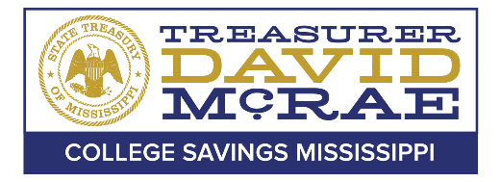

Office of the State Treasurer
College Savings Mississippi Board of Directors

Board of Directors Meeting
June 09, 2021– 10:00AM

A meeting of the College Savings Mississippi Board of Directors will be held June 09, 2021, at 10:00AM, pursuant to Miss. Code Ann. § 25-41-5 (5). This meeting will be held via teleconference. For additional information about this meeting, please contact the Office of the State Treasurer College Savings Division at 601-359-3600.

Disabled persons needing special accommodation(s) to fully participate in this meeting should contact the College Savings Mississippi office at 601-359-5255.

