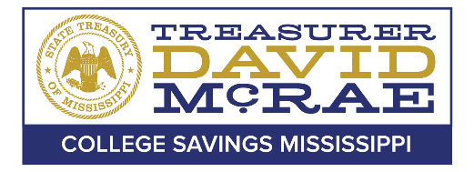

Office of the State Treasurer
College Savings Mississippi Board of Directors

Audit Committee Meeting
December 15, 2020 – 10:00AM

A meeting of the College Savings Mississippi Audit Committee will be held December 15,
2020, at 10:00AM, pursuant to Miss. Code Ann. § 25-41-5 (5). This meeting will be held via teleconference. The public may attend in the Capitol Conference Room at the E.T. Woolfolk Building in Jackson, Mississippi. For additional information about this meeting, please contact the Office of the State Treasurer College Savings Division at 601-359-3600.

Disabled persons needing special accommodation(s) to fully participate in this meeting should contact the College Savings Mississippi office at 601-359-5255.

