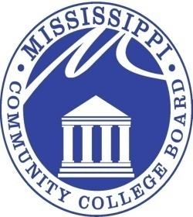

MISSISSIPPI COMMUNITY COLLEGE BOARD

M E E T I N G N O T I C E

FROM: Eric Clark
MCCB Executive Director

RE: Board Meeting Notice

DATE: July 1, 2015

The next regular monthly meeting of the Mississippi Community College Board will be held at 9:00 a.m. CST, Friday, July 10, 2015, in the Magnolia H conference room of the Beau Rivage, located at 875 Beach Blvd, Biloxi, MS 39530. This meeting may be conducted as a teleconference meeting.

3825 RIDGEWOOD ROAD, JACKSON, MISSISSIPPI 39211 601-432-6684

