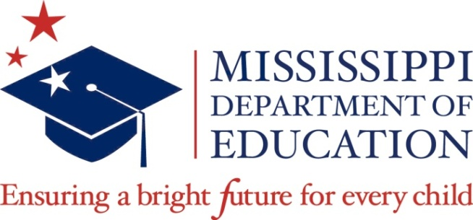

NOTICE

MISSISSIPPI DEPARTMENT OF EDUCATION

Academic Achievement PK-12 Subcommittee Meeting

The members of the Academic Achievement PK-12 Subcommittee of the Mississippi Board of Education will meet on Wednesday, October 18, 2017 at Mississippi Department of Education, Central High School Building, 359 North West Street, Jackson, Mississippi, in Suite 311 at 3:30 p.m. to discuss resources and professional development updates and School Improvement Grants.

Posted: October 6, 2017

