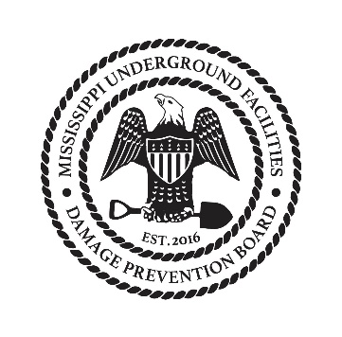
Underground Facilities Damage Prevention Board
Agenda 07-12-2017

- Call to order
- Reading and approval of Minutes from June
- Committee Updates
  - Executive – complaint count
  - Technical – Updates on web
  - Training – Testing update
  - Financial – Update and Treasurer search
  - Rules and Regulations – Update on revisit of rules
- Old business
- New business
- Close

