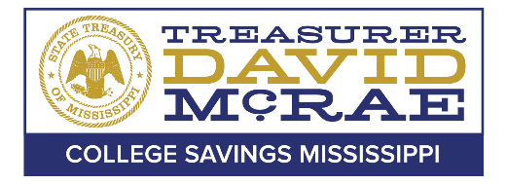

Office of the State Treasurer
College and Career Savings Mississippi Board of Directors

Board of Directors Meeting
April 11th, 2024- 10:00AM

A meeting of the College and Career Savings Mississippi Board of Directors will be held April 11th, 2024, at 10:00AM, pursuant to Miss. Code Ann. § 25-41-5 (5). This meeting will be held at the Butler Snow Building in Ridgeland, MS and via teleconference. For additional information about this meeting, please contact the Office of the State Treasurer College and Career Savings Division at 601-359-5255.

Disabled persons needing special accommodation(s) to fully participate in this meeting should contact the College Savings Mississippi office at 601-359-5255.

