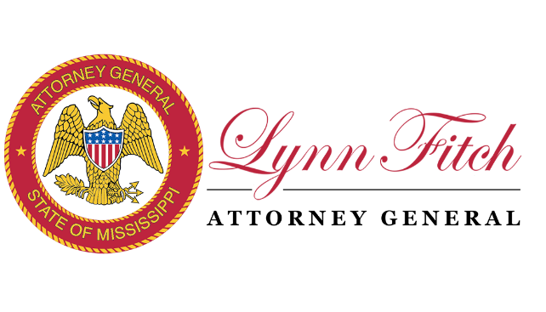

**NOTICE OF MEETING**

**of the**

**VICTIMS OF HUMAN TRAFFICKING AND COMMERCIAL SEXUAL EXPLOITATION FUND COMMITTEE**

Pursuant to the provisions of Mississippi Code Annotated Sections 25-41-1 *et seq*. (1972), notice is hereby given of a meeting of the Victims of Human Trafficking and Commercial Sexual Exploitation Fund Committee to be held on Thursday, January 9, 2025, beginning at 12:00 p.m. in Media Room 1307 of the Offices of the Mississippi Attorney General, 550 High Street, Jackson, Mississippi. The purpose of the meeting is to conduct the regular business of the Committee as set forth in the attached Agenda.

This the 8th day of January, 2025.

BY:  */s/ Abigail C. Overby*

Abigail C. Overby

Special Assistant Attorney General