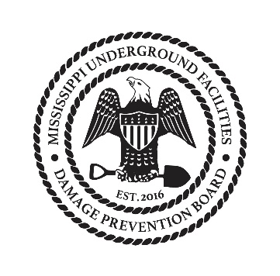
Underground Facilities Damage Prevention Board
Agenda 06-21-2017

- Call to order
- Reading and approval of Minutes from April
- Committee Updates
  - Executive – complaint count
  - Technical – Updates on web
  - Financial – Update and Treasurer search
  - Training – Testing update
  - Rules and Regulations – Update on rule Status
- Old business
  - Consider public comments to proposed board rules and consider adoption of final rules
- New business
- Close

